QForm UK Direct
Metal forming plants often face with design tasks of new forging parts. Designed technologies may have various defects in forging part:
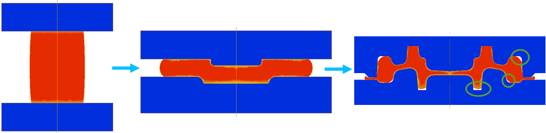
QForm UK Direct engineering software creates die cavity shapes for preliminary dies. Forging die engineers are enabled to obtain shapes in the automated way based on the design of the final forging part. Defect-free part after the whole forging process – is the main task which QForm UK Direct is solving. QForm UK Team offers a modification of the existing forging process, by designing new preliminary dies for bulk forging processes. For 3-transitional processes, when a first operation is upsetting or flattening operation, our team could consider the design of the whole forging process from the start.
As outcomes results QForm UK Team provides:
- 3D models of the optimal preliminary dies (STEP format)
- Confirmation of defect-free technology by simulation (qform-file, metal flow animations, other results)
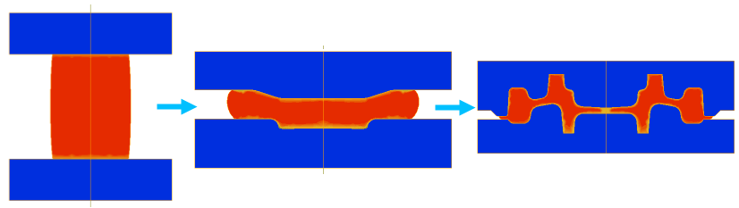
Examples of forging technologies where preliminary dies have been already designed by QForm UK Direct:
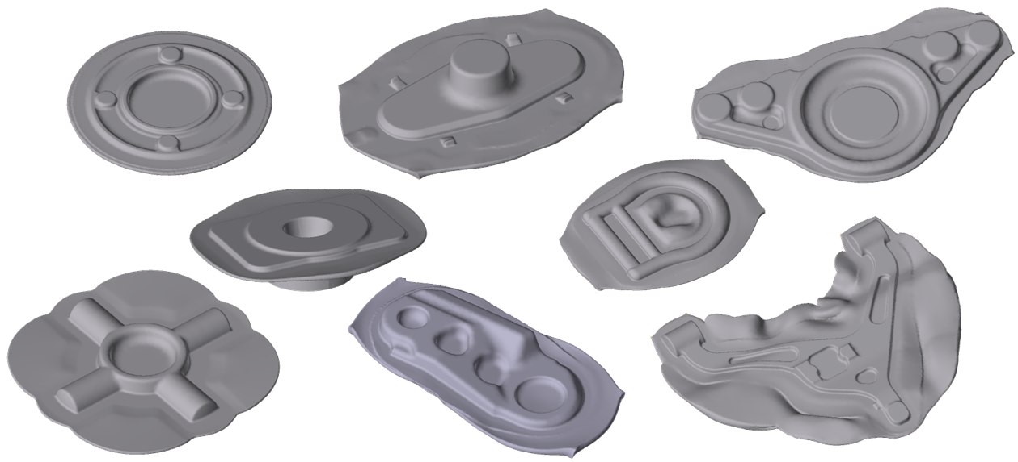

Data that must be submitted:
- 3D model of dies for final operation (step or igs files) and preliminary operations as upsetting or flattering (if they take place)
- Die block sizes that could be used for preliminary dies
- Main problems of the technological process
- Initial data of technological process
Fill the table of initial data:
Number of operations in existing process: |  |  |  |  | 3
Specify technological process properties below.
Workpiece parameters:
Material | - | Initial temperature, [˚C] |  |  | -
Tool parameters:
Select one of  Equipment  type | Mechanical press | ☐ | Hydraulic press |  | ☐
 | Hammer | ☐ | Screw press |  | ☐
Material | - | Temperature, [˚C] | - | Lubricant | -
Select one of stop conditions (final operation):
Final distance between the tools, [mm]
Tool stroke, [mm]
Number of blows (hammer, screw press)

Specify parameters of selected equipment:
Mechanical press |  |  | Hydraulic press
Strokes per minute |  |  | Maximum Load, MN
Height of stroke, mm |  |  | Nominal velocity, mm/s
Ratio of crank radius to connecting rod |  |  | Direct drive or accumulator drive
Load, MN
Hammer |  |  | Screw press
Blow Energy, kJ |  |  | Maximum energy, kJ
Weight of the upper moving die block, ton |  |  | Nominal energy, kJ
Weight of the lower moving die block, ton (only for counter blow hammer) |  |  | Maximum velocity, mm/s
 |  |  | Maximum Load, MN
 |  |  | Nominal Load, MN

Technological parameters: transportation and pause time
 | Operation 1 | Operation 2
Cooling in air, sec
(before the first action)
Cooling in tool, sec
(before the first action)
*Cooling in air, sec
(between the actions)
*Cooling in tool, sec (between the actions)

Additional data that could be provided:
- Previous results as photo or video materials
- Simulation results (images, animations)
- Helpful comments

